NUMURKAH PRE-SCHOOL ASSOCIATION INC.

No. A0037483U

P.O. Box 22, Numurkah 3636

18 McCaskill Street, Numurkah 3636

Telephone (03) 5862 1569
Email numurkah.kin@kindergarten.vic.gov.au
Website www.numurkah.kindergarten.vic.gov.au

Bush Kinder

Program Handbook

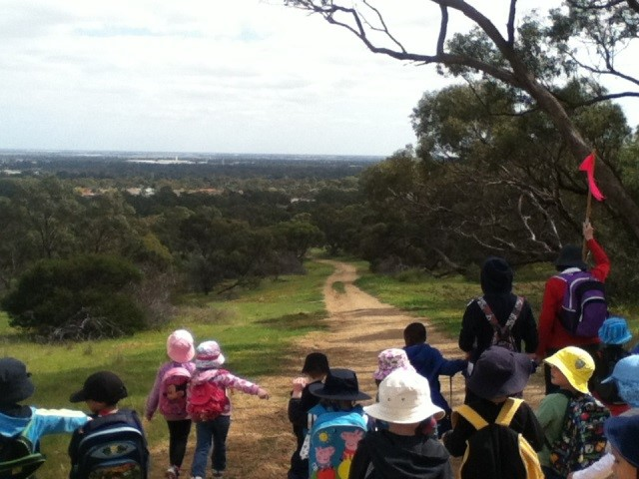

Contents

PARTICIPATION .................................................................................................................. 3 COMMUNICATION................................................................................................................ 3
PROGRAM OVERVIEW ........................................................................................................ 4
SESSION OVERVIEW............................................................................................................ 4
STAFF .................................................................................................................................. 5 ATTENDANCE....................................................................................................................... 5
When shouldn’t my child attend............................................................................................. 5
Others in attendance .............................................................................................................. 5
Volunteers .............................................................................................................................. 5
SESSIONS ............................................................................................................................ 6
Session times.......................................................................................................................... 6
Session cancellation............................................................................................................... 6
WEATHER.............................................................................................................................. 6
CLOTHING ............................................................................................................................. 7
Clothing provided by Kindergarten.......................................................................................... 8
Identification on clothing ........................................................................................................ 8
WHAT ELSE TO BRING....................................................................................................... 8 Water..................................................................................................................................... 8 Food....................................................................................................................................... 8
Footprints ............................................................................................................................... 8
LOCATION ............................................................................................................................. 8
Bush Kinder Site..................................................................................................................... 8
Bush Kinder Home Base ........................................................................................................ 9
Parking Area........................................................................................................................... 9
PICK UP AND DROP-OFF.................................................................................................... 9 TOILETS................................................................................................................................ 9
DIAGNOSED MEDICAL CONDITIONS AND MEDICATIONS............................................. 10
TRAINING AND AWARENESS SESSIONS.......................................................................... 10
RISK ASSESSMENT ........................................................................................................... 10
FURTHER POLICY AND REGULATIONS............................................................................ 10
Full Policy documents are available for review at Numurkah Kindergarten ………………… 10
Bush Kinder Policies.............................................................................................................. 10
EMERGENCY EVACUATION............................................................................................... 11
Safe Zone Assembly Points and Routes................................................................................11

PARTICIPATION:
To participate in this program parents/carers must complete and return to kinder prior to the first session a Bush Kinder Permission Form (Regular Outing). Parents/carers should also provide any changes to their enrolment forms including updating the list of authorised people to collect your child.
COMMUNICATION:
We ask parents to always have their mobile phone with them and turned on throughout the duration of their bush kinder session to be easily contactable when necessary and aware of any updates throughout the session.

Please enter relevant numbers to your phone:
Contacts for Bush Kinder in session:
Mobile Phone at site | 0458980535
Numurkah kindergarten | 0358621569
Mobile Phone Numurkah Kindergarten | 0456054316

PROGRAM OVERVIEW
At Numurkah Kindergarten we believe childhood is precious and that an important part of childhood is being outside in nature. Contact with the outdoors is often limited for many children in modern society, and the vital experience of using the outdoors and being comfortable in nature is being lost. We know in our hearts that children need more time outside in nature. This knowledge is supported by research. Numurkah Kindergarten’s Bush Kinder program is intended to support young children through play, to develop responsibility for themselves and others. It will encourage early risk self-assessment strategies that will ensure that young children start to consider the impact of their actions on themselves and on others. In so doing, children learn to take on challenges and accept responsibility. Children are natural learners. Bush Kinder will provide your child with the time and an ideal environment for them to learn in: Up to 6 hours of uninterrupted play in the bush, using what nature has provided as learning materials. Bush Kinder will be a special part of your child’s total kinder experience. They will have the opportunity to play in the rain, roll down grassy mounds, balance along fallen logs, get involved in dramatic play, find insects and draw with sticks in the ground. Each child’s developmental progression, advancing skill levels and particular interests will be noted by their teachers. The teachers will use this knowledge to support the children’s learning just as they do at home kinder. Teachers will support children as they take the risks and face challenges essential to well-rounded learning. Stories will be told, knowledge will be shared, songs will be sung. At times a specialist may assist the children’s learning. We may also engage the expertise of a musician or a crafts person if this will support the children's learning. We will encourage involvement of the aboriginals who have a spiritual and historic connection with this land. Through play your children will connect with and respect this space. They will connect with their land in a way that cannot be done under a roof or within walls.

SESSION OVERVIEW
Prior to the commencement of each session, teachers will scan the bush space for safety and new areas of potential interest. Each Bush Kinder session will begin with the group meeting together with the teachers at home kindergarten then the children will walk to Bush kinder. When the children and staff arrive at Bush kinder a story may be told or a group discussion may take place.
The natural boundary markers of the Bush Kinder site will be pointed out and discussed as required with the children.
The children will then be free to engage in play within the boundaries of the Bush Kinder site.
After about an hour the children will be gathered to sit together, chat, eat a snack and have a drink. The children will then be free to re-engage in play until the session concludes.

STAFF:
Four qualified kindergarten teachers and educators attend each session. The staff to child ratio is four staff to thirty children. This ratio may be reduced to three staff and thirty children if a staff member is required to leave the area [for example, to collect additional water etc]. Volunteer involvement may increase this ratio. All our qualified staff have a passion for seeing our children learning in natural environments. The groups will have their teaching team attend the bush session.
ATTENDANCE:
When shouldn’t my child attend:
We ask that parents/carers are diligent and exercise their own judgement in assessing whether it is appropriate for their children to attend Bush Kinder.
Children should not attend Bush Kinder if they are:
- ill, excessively tired
- if parents are concerned about their well-being due to forecast weather conditions.
Others in attendance to ensure our kindergarten children are given freedom to play and engage with nature we ask that adults are always respectful of their space. Parents and carers are always welcome to stay and be involved in sessions and are asked to indicate their intention at the commencement of the session.
Volunteers:
Volunteers must register and gain approval for attendance at each session from staff. Volunteers will be required where the staff determine that additional adult supervision is required to ensure the safe running of the program. This may include for example, the creek becoming fast flowing as a result of high rainfall during the week, or to provide additional support for a bush walk undertaken through the park.
Volunteers always remain under the direct supervision of the Lead Teacher (Responsible Person) throughout the session. Parents, carers and grandparents are welcome to volunteer to assist with sessions, including setup, pack up and to provide extra adult supervision where required as identified by staff. It is desirable that all volunteers hold a Working With Children Check (forms available from post offices, free to apply), though parents and carers are welcome to volunteer regardless.
Volunteers are required to complete a Volunteers form available from the kindergarten

SESSIONS:
Session times Bush Kinder sessions run every week during kindergarten terms.
Cockatoos | Tuesday
Parrots | Thursday

Groups are allocated to maintain staff ratios and appropriate group sizes for learning.
Session cancellation:
Sessions may be cancelled ahead of time, at short notice or during a session, in the following circumstances:
Reasons for cancellation | Notification | Contact Person

Staff Absence | SMS on morning of session | Kindergarten teacher

Extreme Weather | SMS to all families | Kindergarten teacher

Sudden extreme weather | SMS to all families | Kindergarten teacher

Emergency Evacuation | SMS to all families | Kindergarten teacher

Note: If on arrival, Bush Kinder is not set up on site, this means that the session has been cancelled.
Where the group has been evacuated or relocated the SMS message to parents/carers will specify the location for pickup.
WEATHER:
Weather information will be obtained from the Bureau of Meteorology website: http://www.bom.gov.au/vic/forecasts/numurkah.shtml
Families will be notified of cancellation and the session will be held at home kindergarten.

CLOTHING:
Parents are required to determine appropriate clothing based on the weather forecast appropriate to their session time. It is important that Bush Kinder participants wear appropriate and protective clothing and footwear which:
- allows children to move freely and undertake activities such as climbing, balancing, running
- keeps children warm and dry in cold/wet weather
- protects children from the damaging effects of the sun, UV rays in warm weather and high UV conditions.
- prevents sunburn, bites, scratches and stings.
- Even in warm weather, long sleeve tops and long pants are recommended - this clothing should be loose fitting and light.
- Where possible is made from natural fabrics which allow the body to breathe and is comfortable against the skin.
- In the case of footwear, keeps feet and toes covered and has a flexible sole to allow children to climb and balance on uneven surfaces
The following table provides examples of recommended clothing, clothing which is not recommended and unacceptable clothing:
 | Warm Weather | Cold Weather / Rain

Recommended clothing and footwear | Light loose fitting long sleeve tops and long pants, broad brimmed hat or legionnaires hat, closed toe shoes | Waterproofs (supplied by Kinder on site), long pants, long sleeved top, beanie, waterproof gloves, thermals in very cold weather

Not recommended | short sleeved tops, long skirts or dresses, shorts | Skirts, dresses (incompatible with Waterproofs)

Unacceptable clothing and footwear | Open toe shoes, sandals, thongs, crocs, singlet tops | Non-waterproof outer clothing. (The supplied waterproofs on top of non-waterproof clothing is recommended).

Waterproofs:
Light rainproof suit worn over clothing, which includes a jacket with a hood, and pants or overalls, which zip up over clothing (supplied by the Kindergarten on-site).

Change of clothes:
All children participating in Bush Kinder may bring a change of clothes and footwear as these may become wet and muddy. It is recommended that the spare clothing include:
- Spare top and bottoms of appropriate thickness/weight for the weather on the day
- Spare underpants (and singlet in winter)
- 2 pairs of socks
- 1 pair of gumboots (it is not recommended that gumboots are worn at all times due to the restriction of movement they impose).
- A bag for dirty/used clothing to be placed.
The Bush Kinder ‘on-site kit’ will contain some spare clothing, waterproofs and gumboots for general use.
On high UV days, please ensure that you apply sunscreen prior to the session commencing. Sunscreen will be available for re-application during sessions.
Clothing provided by Kindergarten:
Waterproof jackets and pants are provided by Numurkah Kindergarten. Kinder staff are responsible for cleaning these clothing items each week as part of the home kinder session and ensure they are brought to each session.
Safety vests will be provided by the kinder with the Numurkah Kindergarten Name and phone number printed on them.
WHAT ELSE TO BRING:
Water
Parents/carers are required to provide a water bottle of fresh water at all sessions. There will be access to drinking water to supplement this when required on site. All participants on site at bush kinder are required to have a water bottle.
Food
Parents/carers are required to provide a snack in a sealed container for each session for their child to eat. We ask you consider the environment by not including any packaging. We also ask you to observe food allergy precautions when selecting items to include.
Footprints
Please always take away with you what you brought in.
Parents and children are asked not to bring toys along to Bush Kinder to better enable children to engage in the natural surrounds.
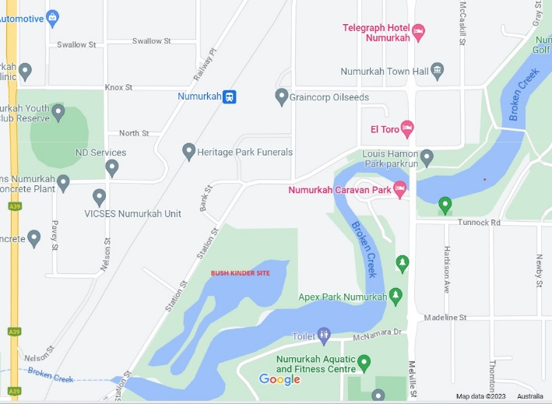
LOCATION
Bush Kinder Site
The Bush Kinder site is in Station Street Wetlands Numurkah. This is a space to connect with nature. You can see native plantings thriving and the 1km path traversing through the wetland including a boardwalk adds to this wetland. The area provides a home for birds, frogs, reptiles, mammals, and insects.
This will be a 1km walk from the kindergarten for the children and staff.

Bush Kinder Home Base
This site has been chosen as the children can walk to and from the site and it gives a comfortable area for children to explore and get to know through the seasons. It provides clear lines of sight with natural boundaries easily identified by staff, children, and volunteers.
We also will have access to the Numurkah Fishing Club, for the storage of equipment that can be left from week to week.
Parking Area
Parking is available onsite. Please take care in the car park.
PICK UP AND DROP-OFF – will be done at home kinder but on the occasions, you may have to drop off or collect your child from bush kinder please follow the below steps at all times:
Bush Kinder signage will be displayed around the perimeter of the site.
Drop-off Parents and carers need to ensure they:
Place child’s bag/backpack with change of clothes, snack and water in allocated place.
Sign the child in using the attendance book and record the time of arrival
Accompany child at home base until the session begins.
All children will assemble here until the Bush Kinder session formally commences.
Apply sunscreen on high UV days.
Dress in waterproof pants and top and appropriate shoes for conditions at site.
Ensure identification sticker is on outer clothing.
Pick-up Parents and carers need to ensure they:
Sign the child out using the attendance book and record the time. Please ensure the staff are aware you have collected your child. Be mindful of not distracting/speaking with staff until all the children have departed. Be responsible for the supervision of the child while still at the Bush Kinder site.
Collect the child’s belongings (bag, water, hats, food containers, rubbish). Hang waterproofs which may be wet/dirty out to air or return to storage bag.
Please refer to main Delivery and Collection of Children Policy for full procedures relating to collection by authorised person, late collection and late collection fees
TOILETS
To maintain required staff ratios as set by regulations at all times. A camping toilet will be provided for children and staff to use when necessary housed in an appropriate tent. Staff will attend to any children requiring assistance. We ask that the broader kinder community (parents, volunteers etc) use the facilities at Numurkah Fishing Club. Parents are requested to encourage children to use the toilet prior to their session.

DIAGNOSED MEDICAL CONDITIONS AND MEDICATIONS
Parents and guardians of children with diagnosed medical conditions are required to provide a Medical Management Plan (completed by a registered medical practitioner) prior to the commencement of the child at Numurkah Kindergarten at the start of the year. Copies of the Medical Management Plan and Medical Risk Minimisation Plan (also completed at the start of the year) for each child are taken to Bush Kinder by kindergarten staff in the Bush Kinder Medication Bag, along with any medications for the child which are normally kept at home kinder. Other medications may be signed in on arrival at Bush Kinder in accordance with the kindergarten’s Administration of Medications Policy, using a Medication Record Sheet, a supply of which are kept in the Bush Kinder Medication Bag.
TRAINING AND AWARENESS SESSIONS
Sessions will be run as part of orientation for staff, children and parents for dog and snake awareness and where identified further training is required. All kindergarten educators have a Level 2 First Aid Certificate.
RISK ASSESSMENT
Extensive risk evaluation has been carried out by the Bush Kinder and is posted at the kindergarten.
FURTHER POLICY AND REGULATIONS
Bush Kinder is conducted as part of the Numurkah Kindergarten program and therefore is governed by the regulations and procedures of the kindergarten. Due to location and environmental factors, variations to policy have been identified and different procedures created which are specific to Bush Kinder to ensure the safety and wellbeing of all children, staff and volunteers involved in the program. We ask parents to view the policies regarding Bush Kinder available at kindergarten to gain a full understanding of the responsibilities of the Numurkah Kindergarten Committee, staff, volunteers, and parents alike. Full Policy documents are available for review at Numurkah Kindergarten.
Bush Kinder Policies
Bush Kinder Delivery and Collection Policy
Bush Kinder Dogs Awareness Policy
Bush Kinder Emergency Evacuation Policy
Bush Kinder Extreme Weather Policy
Bush Kinder Identification and Visibility Policy
Bush Kinder Protective Clothing Policy
Bush Kinder Snake Awareness Policy
Please contact us if you would like to discuss any concerns or queries.

EMERGENCY EVACUATION
There are times that have been identified that require the Bush Kinder participants to evacuate to a safer location to ensure the safety and wellbeing of the group. In this event, Bush Kinder staff will notify parents via a text message.
Parents are asked to familiarise themselves with the designated safe areas and assembly points as detailed in the emergency evacuation maps. The reasons for relocating include, but are not limited to: Fire or Bushfire, missing child, aggressive dogs off leads, other animal intruders, uninvited person/stranger (threatening, causing a nuisance or unease for staff and participants), natural events, such as extreme weather, floods, severe winds or thunderstorm, medical emergency or accident.
Safe Zone Assembly Points and Routes:
The safe zone assembly points will differ depending on the nature of the emergency:

TORRENTIAL RAIN, HAIL  Assembly Point A: All children and staff to assemble and make way to the Fishing Club  Group to wait here until torrential rain and/or hail has passed and it is safe to resume normal activities.  Shelter may be sought in the Numurkah Fishing Club if the weather shows no signs of abating (see Assembly Point B below).  Route: Take shortest safe route possible | 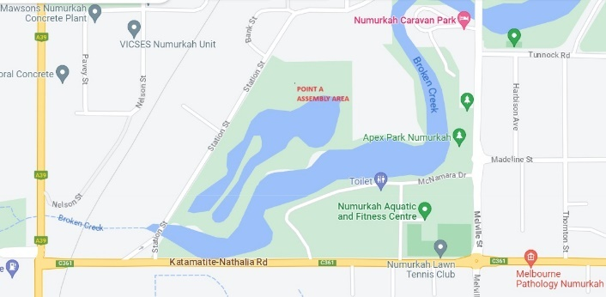

ELECTRICAL STORM, EXTREME WINDS  Assembly Point B: Fishing Club (next door to shire outdoor yard)  Group to wait here until storm passes and safe  to resume activities (recommend 30 minutes  after electrical storm activity has ceased)  Route: Take shortest safe route possible | 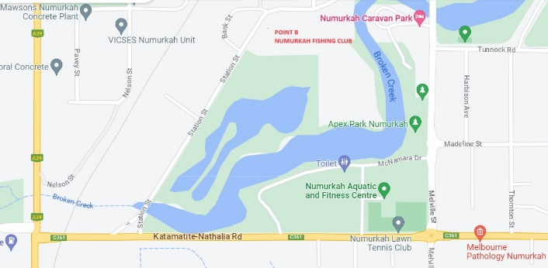

ALL OTHER EMERGENCY EVACUATION  SITUATIONS  When it is not necessary to evacuate Station Street Wetlands all together:  Assembly Point C: Beside the shire depot  (chosen for its central point close to Parklands  staff and for ease of communications)  Route: Assemble children to beside car park area and make way across to the shire depot | 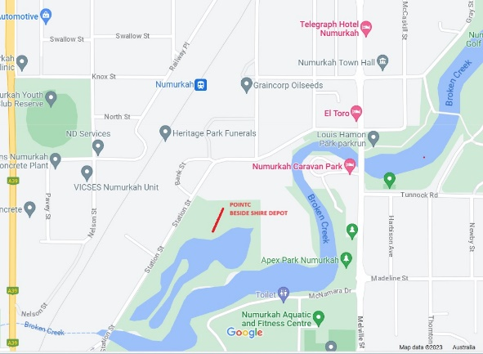

ALL OTHER EMERGENCY EVACUATION  SITUATIONS  When it is necessary to evacuate Station Street Wetlands Numurkah altogether:  Assembly Point D:  Route: Assemble in car park area and walk past the Numurkah Fishing club making way to the park on the corner (See red lines on map for route) | 