NUMURKAH PRE-SCHOOL ASSOCIATION INC.

No. A0037483U

P.O. Box 22, Numurkah 3636

18 McCaskill Street, Numurkah 3636

Telephone (03) 5862 1569
Email numurkah.kin@kindergarten.vic.gov.au
Website www.numurkah.kindergarten.vic.gov.au

Bush Kinder Emergency Evacuation Policy
NQS: Quality Area 2

Purpose
This policy is a special circumstance policy which augments the main Numurkah Kindergarten Emergency Evacuation Policy and the Incident, Injury, Trauma & Illness Policy and should be read in conjunction with those policies. This Bush Kinder policy only details the specific evacuation procedures for children, staff and volunteers attending the Bush Kinder program in response to an emergency or hazard that may arise during a session.

This policy aims to:
● Set out clear and safe evacuation principles and procedures for Bush Kinder participants in response to an emergency situation of any type
● Increase awareness and implementation of emergency and evacuation procedures at Bush Kinder amongst staff and the broader kindergarten community
● Provide an appropriate mechanism for communication of the evacuation procedures for requirements for Bush Kinder sessions to parents and to children.
Policy statement
1. Values
Numurkah Kindergarten is committed to:
● Providing a safe environment for children, staff and volunteers participating in the Bush Kinder program
● Ensuring that an appropriate response is provided, which meets the needs of participants during and following emergency incidents
● Providing effective procedures in place to manage emergency incidents at the Bush Kinder site.
2. Scope
This policy applies to children, parents, staff, committee members, authorised persons, volunteers and students on placement working at Numurkah Kindergarten.
3. Background and legislation
There are a multitude of possible emergency situations that may arise at Bush Kinder.
These include, but are not limited to:
● Fire / Bushfire
● Chemical hazards
● Missing child
● Aggressive dogs off leads
● Other animal intruders
● Uninvited person/stranger (threatening, causing a nuisance or unease for staff and participants)
● Toxic leak
● Hostage/siege
● Natural events, such as extreme weather, floods, severe winds, thunderstorm or earthquake
● The involvement of firearms or other weapons
● Hazardous substances incidents
● Medical emergency (refer to Incident and medical emergency management policy)
● Accident.

The aim of this policy is to provide the appropriate response to such an incident or emergency to ensure the safety and wellbeing of all Bush Kinder participants.
Relevant legislation includes but is not limited to:
● Education and Care Services National Regulations 2011
● Education and Care Services National Law 2010
● National Quality Standards, including Quality Area 2 – Children’s health and safety
and Quality Area 3 – Physical environment
● Occupational Health and Safety Act 2004
● Occupational Health and Safety Regulations 2007
4. Definitions
Assembly point: A predetermined and mapped safe place for the Bush Kinder group to
meet after an emergency evacuation. [Refer to Attachment 1 for Bush Kinder assembly
points]

Emergency: A sudden, unforeseen crisis (usually involving danger) that requires immediate
action.
Emergency drill/rehearsal: A process to rehearse anticipated emergency scenarios or
events, designed to help clarify roles and responsibilities, provide training and verify the
adequacy of the emergency response
Emergency Management Plan (EMP): A written set of instructions for the service to
prepare for and respond to emergencies. A guide to preparing an emergency plan and an
Emergency Management Plan templates are available on the DET website (refer to
Sources)
Emergency services: Includes ambulance, fire brigade, police and state emergency services
https://info.australia.gov.au/information-and-services/public-safety-and-law/emergency-services
Emergency evacuation: Emergency evacuation is the immediate and rapid movement of
people away from the threat or actual occurrence of a hazard.

Evacuation route: A predetermined and mapped safe route to move people away from a
threat or danger. At Bush Kinder, the route taken will depend on the emergency/danger.
[Refer to Attachment 1 for Bush Kinder evacuation routes]

Hazard: The potential to harm a person’s health or safety that can arise from the
environment, equipment and substances, poor work design and inappropriate practices and
procedures.

Incident Management Team (IMT): Is the group of incident management personnel comprising of the incident controller and other personnel appointed to be responsible for the functions of operations, planning, and logistics
Risk management: A structured approach to managing uncertainty related to a threat; a
sequence of activities including the identification, assessment and prioritisation of risks
followed by co-ordinated and economical application of resources to minimise, monitor and
control the probability and/or impact of those risks.

WorkSafe Victoria: The manager of Victoria’s workplace safety system.

5. Sources and related policies
Kindergarten policies
● Bush Kinder Delivery & Collection of Children Policy (Bush Kinder Specific)
● Bush Kinder Extreme Weather Policy (Bush Kinder Specific)
● Bush Kinder Identification and Visibility Policy (Bush Kinder Specific)
● Bush Kinder Protective Clothing Policy (Bush Kinder Specific)
● Bush Kinder Snake Awareness Policy (Bush Kinder Specific)
● Bush Kinder Dog Awareness Policy (Bush Kinder Specific)
● 2.5 Incident, Injury, Trauma & Illness Policy (including First Aid)
● 2.10 Supervision of Children Policy
● 2.12 Excursion & Regular Outing Policy
● 2.15 Clothing Policy
● 2.16 Sun Protection Policy
● 2.17 Water Safety Policy
● 3.1 Learning Spaces Policy
● 7.5 Occupational Health & Safety Policy

Procedures
General
The Committee is responsible for:
● Following all requirements in Numurkah Kindergarten’s main Emergency Evacuation
Policy and the Incident, Injury, Trauma & Illness Policy

● Establishing, monitoring and reviewing the Bush Kinder Risk Register which identifies
a number of potential hazards and risks and mechanisms for their treatment.

● Establishing, monitoring and reviewing (in consultation with staff) emergency
evacuation procedures, a series of safe evacuation routes and assembly points in
repsonse to a range of potential emergency situations [Refer to Attachment 1 for
Bush Kinder evacuation procedures, routes and assembly points]

● Ensuring emergency evacuation procedures are included in teachers’ documentation carried at Bush Kinder

● Ensuring a fully equipped first aid kit is included with the Bush Kinder gear and equipment

● Ensuring all teachers and volunteers are aware of the location of first-aid kit at Bush Kinder.

● Developing a regular training schedule for Bush Kinder staff that includes the operation of communication systems, evacuation procedures, including evacuation routes and safe places; and occupational health and safety and first aid
● Ensuring that all children, staff, parent, students, volunteers and visitors understand the requirements of this policy including conducting practice drills.
● Ensuring new Bush Kinder staff, students and volunteers have an understanding of the Bush Kinder policy and procedures in relation to emergency evacuation in their induction procedure
● Ensuring procedures are in place at Bush Kinder to identify which staff are in attendance at any one time, such as the sign-in sheet. This can then be used to ensure that all staff are accounted for in the event of an emergency.

Staff are responsible for:
● Ensuring the safety of the children, fellow staff members and volunteers in their care and protecting them from hazards at Bush Kinder
● Safely evacuating children and themselves in the event of an emergency situation
● Ensuring that all children, staff and volunteers are accounted for in the event of an evacuation
● Being aware of the Bush Kinder evacuation procedures set out in this policy, along with the evacuation routes and assembly points in the different emergency scenarios as set out in Attachment 1.
● Providing awareness and support to children before, during and after emergencies
● Providing input into the development of procedures to be followed in the event of an emergency situation, and contributing to the review of the procedures following an emergency incident
● Informing the committee/service coordinator and reporting notifiable incidents to the DET.
Parents are responsible for:
● Reading and being familiar with the policy
● Bringing relevant issues to the attention of both staff and committee
● Ensuring children are signed in and out as per the requirements of the kindergarten’s Delivery and Collection of Children Policy (both the main policy and the Bush Kinder Policy)
● Supporting children’s awareness and education in emergency situations
● Following the directions of staff during an emergency, incident or drill.

Evaluation
In order to assess whether the policy has achieved the values and purposes the committee
will:
● Seek feedback regarding this policy and its implementation with parents of children participating in the Bush Kinder program. This can be facilitated through discussions and the annual centre survey.

● Ask staff to share their experiences and observations in relation to the effectiveness of this policy.

● Regularly review the policy and centre practices to ensure they are compliant with any new legislation, research or best practice procedures.

Attachments
Attachment 1: Bush Kinder Evacuation Procedures, Assembly Points and Evacuation Routes
Authorisation
Endorsed by the Numurkah Kindergarten Committee of Management on 17th October 2023.
Review Date
This policy will be reviewed every two years and is next due for formal Committee review in
2025, unless deemed necessary earlier.

ATTACHMENT 1
Safe Zone Assembly Points and Routes:
The safe zone assembly points will differ depending on the nature of the emergency:
TORRENTIAL RAIN, HAIL  Assembly Point A: All children and staff to assemble and make way to the Fishing Club  Group to wait here until torrential rain and/or hail has passed and it is safe to resume normal activities.  Shelter may be sought in the Numurkah Fishing Club if the weather shows no signs of abating (see Assembly Point B below).  Route: Take shortest safe route possible | 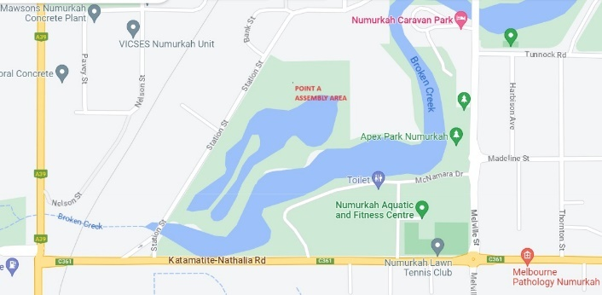

ELECTRICAL STORM, EXTREME WINDS  Assembly Point B: Fishing Club (next door to shire outdoor yard)  Group to wait here until storm passes and safe  to resume activities (recommend 30 minutes  after electrical storm activity has ceased)  Route: Take shortest safe route possible | 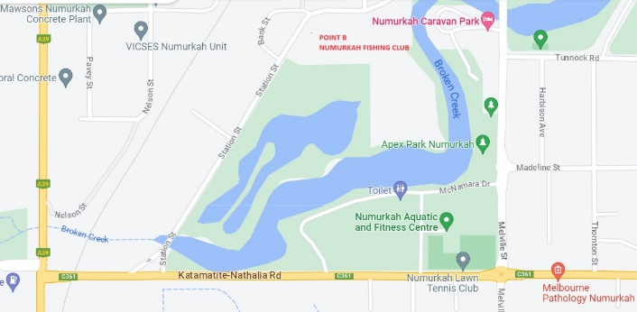

ALL OTHER EMERGENCY EVACUATION  SITUATIONS  When it is not necessary to evacuate Station Street Wetlands all together:  Assembly Point C: Beside the shire depot  (chosen for its central point close to Parklands  staff and for ease of communications)  Route: Assemble children to beside car park area and make way across to the shire depot | 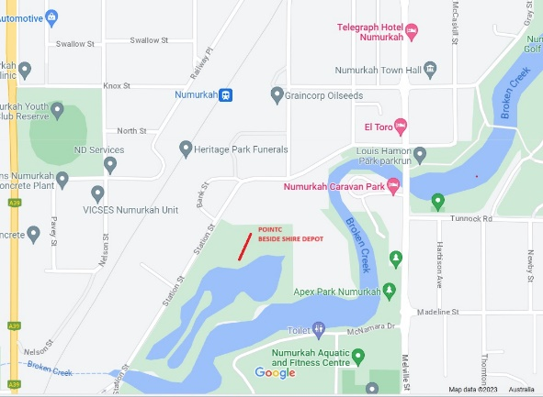

ALL OTHER EMERGENCY EVACUATION  SITUATIONS  When it is necessary to evacuate Station Street Wetlands Numurkah altogether:  Assembly Point D:  Route: Assemble in car park area and walk past the Numurkah Fishing club making way to the park on the corner (See red lines on map for route) | 